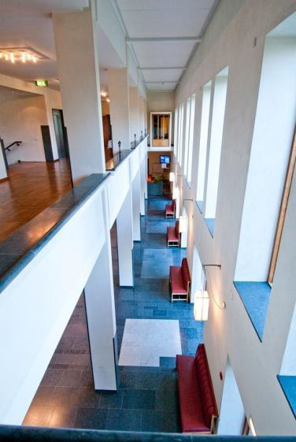
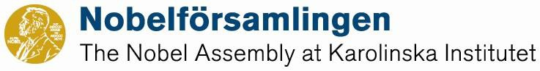

Nobel Conference No. 62
Combat Metabolic Diseases – New Strategies
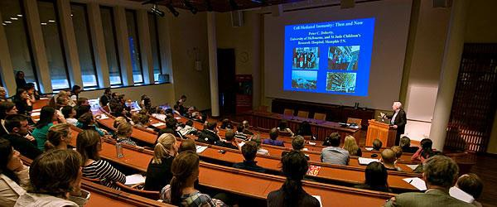
Nobel Forum, Karolinska Institutet, Stockholm, May 28 - 29, 2015

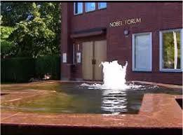

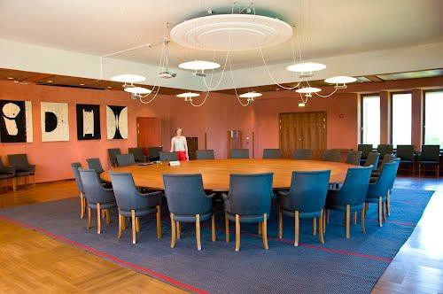

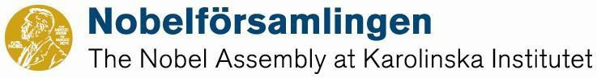

Nobel Conference No. 62
Combat Metabolic Diseases – New Strategies
Nobel Forum, Karolinska Institutet, Stockholm, May 28 - 29, 2015

Day 1 Thursday 28th of May
08:15 - 09:00 Registration

09:00 - 09:10 Welcome Note
Per -Olof Berggren, Kerstin Brismar, Juleen Zierath

09:10 - 09:30 Living with Diabetes
Karin Hehenberger, Karolinska Institutet and Lyfebulb, NY, USA

Islet Cell Biology and Pathophysiology
Chair: Helena Edlund, Umeå University, Sweden

09:30 - 10:00 Insight into Pancreatic Islet Cell Physiology/Pathology
P-O Berggren, Karolinska Insitutet

10:00 -10:30 Treating Types 1 and 2 Diabetes without Insulin: Rationale and Results
Roger Unger, Southwestern Medical School, University of Texas, Dallas, TX, USA

10:30 - 11:00 COFFEE BREAK

11:00 - 11:30 Genetic Insights into Human Beta Cells
Andrew Hattersley, University of Exeter Medical School, Exeter, UK

Regulation of Metabolism through Specific Cell Signaling
Chair: Claes-Göran Östenson, Karolinska Institutet

11:30 - 12:00 New Mechanisms of Insulin Receptor Signaling and Tissue Crosstalk in Insulin Resistance
C Ronald Kahn, Joslin Diabetes Center, Harvard Medical School, Boston, MA, USA

12:00 - 13:30 LUNCH AT NOBEL FORUM

13:30 - 14:00 FGF21: Fasting, Feasting and Pharmacology
David J Mangelsdorf, Southwestern Medical School, University of Texas, Dallas,TX, USA

14:00 - 14:30 AMP - Activated Protein Kinase: Regulating Energy Balance at the Cellular and Whole
Body Levels
Grahame Hardie, University of Dundee, Dundee, Scotland, UK

14:30 - 15:00 Altered DNA methylation of glycolytic and lipogenic genes in skeletal muscle and liver from obese and type 2 diabetic patients
Juleen Zierath, Karolinska Institutet

15:00 - 15:30 COFFEE BREAK

Regulation of Food Intake and Energy Balance
Chair: Martin Ingvar, Karolinska Institutet

15:30 - 16:00 Leptin and the Neural Circuit Regulating Food Intake and Metabolism
Jeffrey Friedman, Rockefeller University, NY, USA

16:00 - 16:30 Metabolic Disease: Lessons from human genetics
Sir Stephen O’Rahilly, Cambridge University, Cambridge, UK

16:30 - 17:00 Role of Gut Microbiota in the Pathogenesis of Diabetes
Fredrik Bäckhed, Wallenberg Laboratories Göteborg University, Sweden

Day 2 Friday 29th of May

Fat metabolism
Chair: Jan Nedergaard , Stockholm University

9:00 - 9:30 Brown and Beige Fat: Mitochondrial Bioenergetics and a Novel Thermogenic Pathway
Bruce Spiegelman, Dana-Faber Cancer Institute, Harvard Medical School, Boston, MA, USA

9:30 - 10:00 Turnover of Human Fat Cells and their Lipid Content
Peter Arner, Karolinska Institutet

10:00 - 10:30 Human Brown Fat as a Therapeutic Target
Sven Enerbäck, Göteborg University, Sweden

10:30 - 11:00 COFFEE BREAK

Late Complications
Chair: Mikael Rydén, Karolinska Institutet

11:00 - 11:30 Diabetes Complications, New Mechanisms
Kerstin Brismar, Karolinska Institutet

11:30 - 12:00 Genetics of Diabetic Nephropathy
Karl Tryggvason , Karolinska Institutet, Duke-NUS Graduate Medical School, Singapore

12:00 - 13:30 LUNCH AT NOBEL FORUM

13:30 - 14:00 Immune Modulation of Lipoprotein Metabolism and Atherosclerosis
Göran Hansson, Karolinska Institutet

14:00 - 14:30 Epigenetic Changes, Oxidative Stress and Vascular Disease in Diabetes
Francesco Cosentino, Karolinska Institutet

14:30 - 15:00 Insulin: the Diabetes-Cancer connection
Lewis Cantley, Weill Cornell Medical College, NY, USA

15:00 - 15:30 COFFEE BREAK

15:30 - 16:15 Discussion and conclusions

